AREA OF ANY TRIANGLE
Pearson Edexcel - Thursday 8 November 2018 - Paper 2 (Calculator) Higher Tier
1.
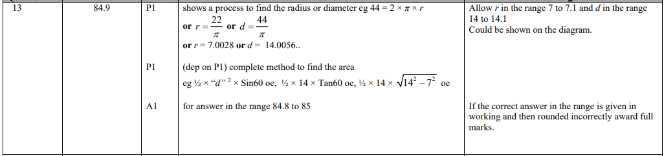
Pearson Edexcel - Thursday 24 May 2018 - Paper 1 (Non-Calculator) Higher Tier
2.
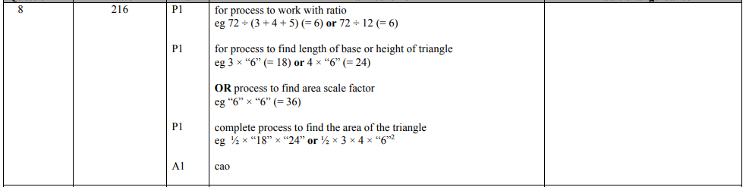
Pearson Edexcel - Tuesday 13 June 2017 - Paper 3 (Calculator) Higher Tier
3.
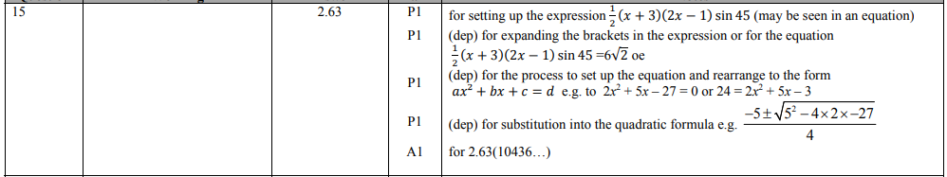
Pearson Edexcel - Specimen Papers Set 2 - Paper 1 (Non-Calculator) Higher Tier
4.
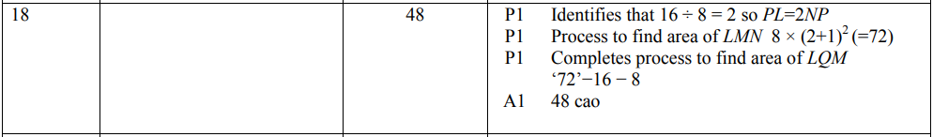

Pearson Edexcel - Specimen Papers Set 2 - Paper 1 (Non-Calculator) Higher Tier
5.
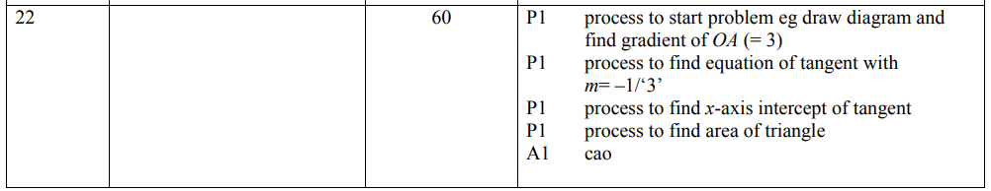
Pearson Edexcel - Specimen Papers Set 2 - Paper 3 (Calculator) Higher Tier
6.
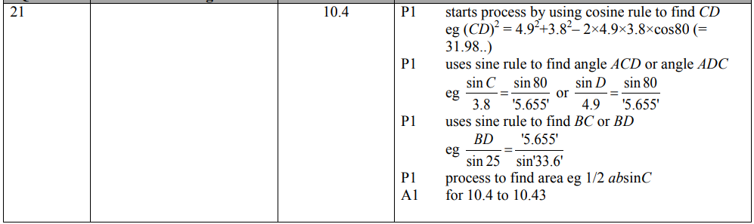
Pearson Edexcel - Sample Paper 2 - (Calculator) Higher Tier
7.
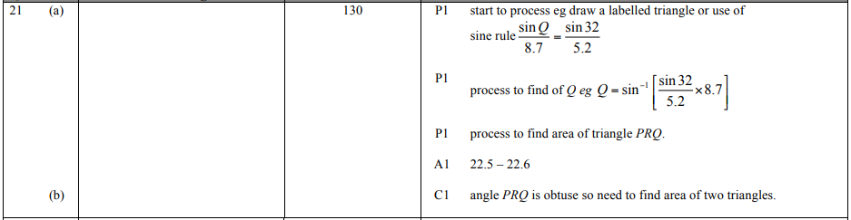
Pearson Edexcel - Friday 8 November 2013 - Paper 2 (Calculator) Higher Tier
8.
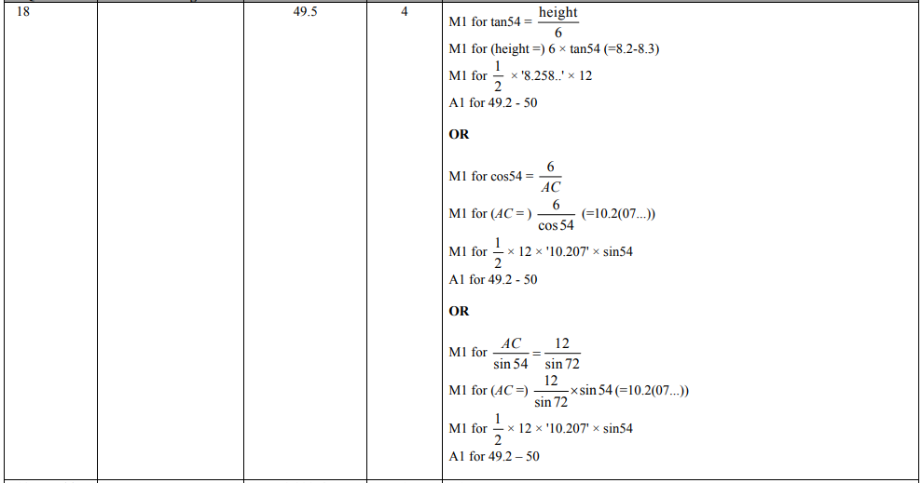
Pearson Edexcel - Tuesday 11 June 2013 - Paper 1 (Non-Calculator) Higher Tier
9.
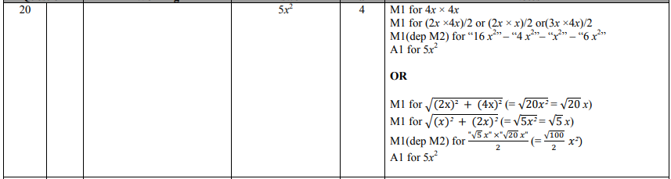
Pearson Edexcel - Friday 14 June 2013 - Paper 2 (Calculator) Higher Tier
10.
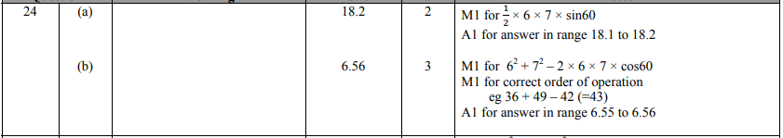
Pearson Edexcel - Tuesday 6 November 2012 - Paper 1 (Non-Calculator) Higher Tier
11.
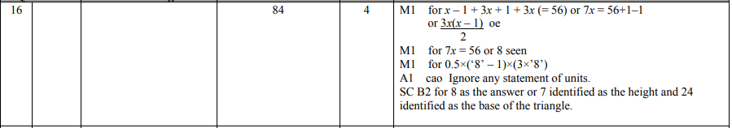
Pearson Edexcel - Monday 11 June 2012 - Paper 1 (Non-Calculator) Higher Tier
12.
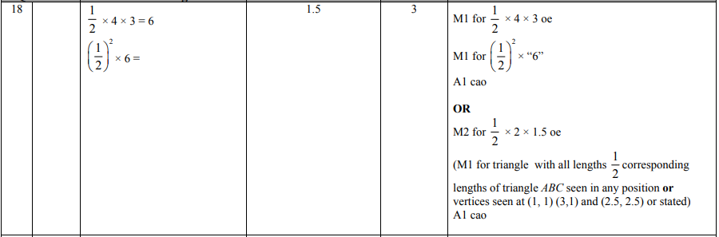
Pearson Edexcel - Wednesday 13 June 2012 - Paper 2 (Calculator) Higher Tier
13.
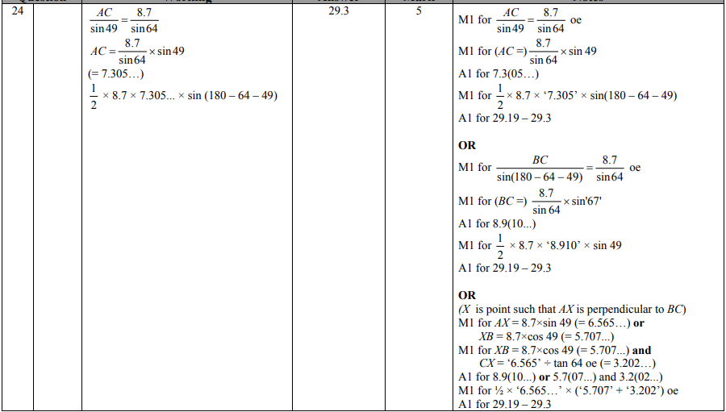

Pearson Edexcel - Friday 12 November 2010 - Paper 4 (Calculator) Higher Tier
14.
Pearson Edexcel - Friday 12 November 2010 - Paper 4 (Calculator) Higher Tier
15.
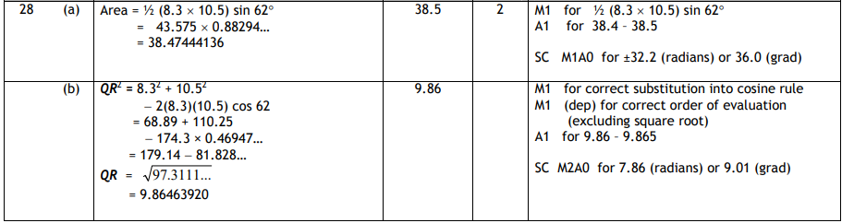
Pearson Edexcel - Friday 11 June 2010 - Paper 4 (Calculator) Higher Tier
16.
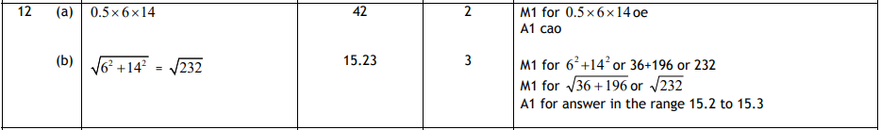
Pearson Edexcel - Tuesday 10 November 2009 - Paper 4 (Calculator) Higher Tier
17.
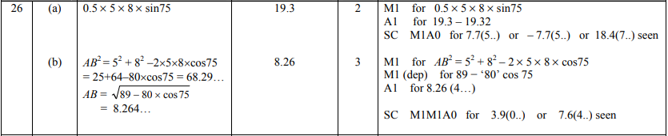
OCR GSCE – Monday 9 November 2020 – Paper 6 (Calculator) Higher Tier
18.
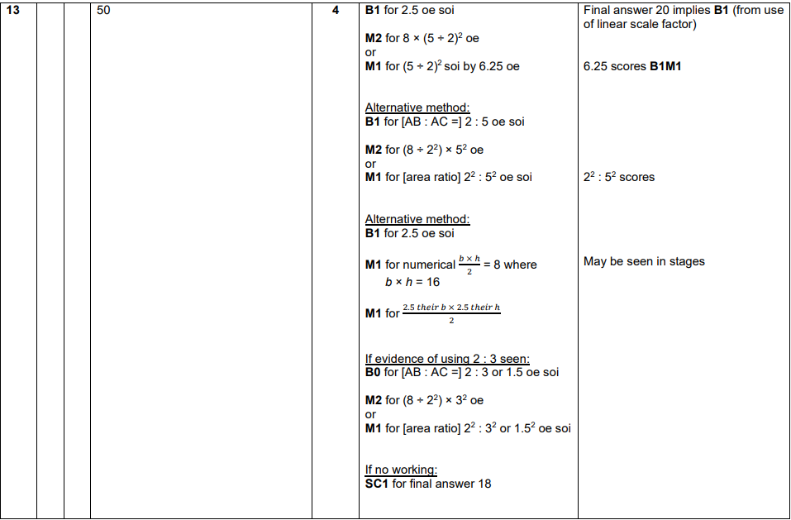
OCR GSCE – Monday 12 November 2018 – Paper 6 (Calculator) Higher Tier
19.
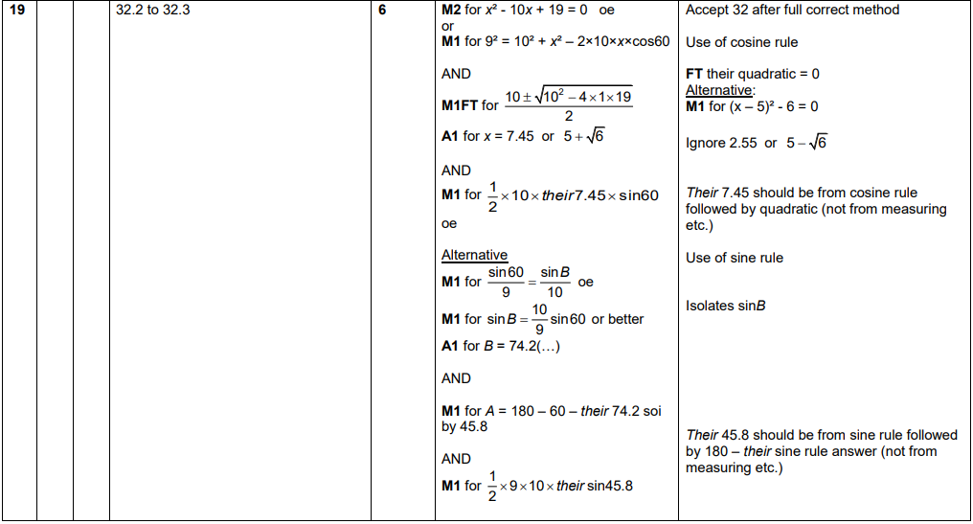

OCR GSCE – Thursday 24 May 2018 – Paper 4 (Calculator) Higher Tier
20.
